Academic Year: 2025-26 | Year: Second Year | Semester: II
PRN No.: 1012411011 | Name: Riddhee Kulkarni
Subject: Python Programming
Assignment Title: Mock Test
Date: 15/04/2026

Problem Statement:
Write a program to input 2 strings. Use a function to check whether they are anagrams. Display result.

Code:
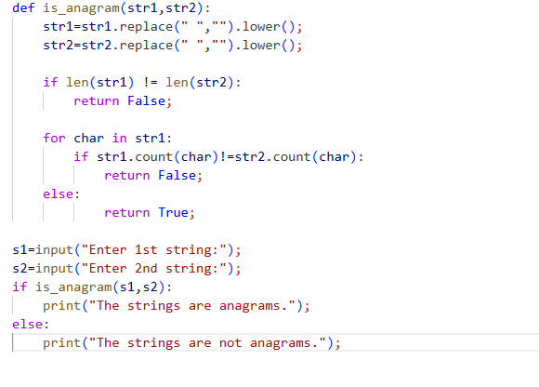

Output:
